 | LITIGATION COUNSEL OF AMERICA™  2018 Fall Conference  & Celebration of Fellows
FACULTY & TOPICS

 | Civil vs. Criminal Trial Techniques: It’s All the Same Once the Jury Is in the Hall  Rusty Hardin  Rusty Hardin & Associates, LLP  Houston, Texas
 | The National Opioid Litigation—Will This Be the Biggest Settlement Ever?  Marc J. Bern  Marc J. Bern & Partners LLP  New York, New York
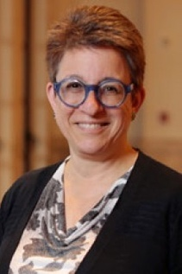 | Update on Attorney-Client Privilege: Tricky Questions in a Complex World  Meryl Macklin  Bryan Cave Leighton Paisner LLP  San Francisco, California
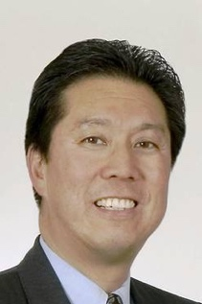 | A World of Difference: Adjusting Your Advocacy to Meet the Contrasting Rules, Customs, and Expectations in U.S. Jury Trial, U.S. Arbitration and Mediation, and International Arbitration Settings  Cedric C. Chao  DLA Piper LLP (US)  San Francisco, California
 | Identifying and Managing Conflicts of Interest in Litigation  Michael L. Hutchinson  Treece Alfrey Musat P.C.  Denver, Colorado

Do Infringers Pay for the Whole Product?
A Dive into Intellectual Property and Apportionment
 |  | 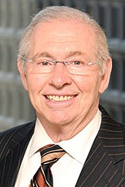 |  |  | 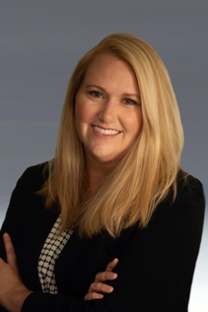
Manny D. Pokotilow  Caesar Rivise, PC  Philadelphia, Pennsylvania |  |  |  |  | Misty L. Decker, CFE, CFF,  CGMA, CLP, CPA/ABV  Elliott Davis  Nashville, Tennessee
#Metoo and Sexual Harassment in a Law Firm:
What to Do When the Worst Happens
 |  |  |  | 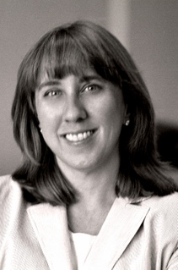 |  | 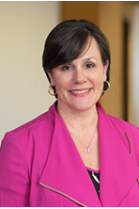
Ross Fishman  Fishman Marketing, Inc.  Highland Park, Illinois |  |  | Donna Phillips Currault  Gordon, Arata, Montgomery, Barnett, McCollam, Duplantis & Eagan, LLC  New Orleans, Louisiana |  |  |  |  | Nora R. Chandler  Director of Client Services  Balch & Bingham LLP  Birmingham, Alabama
Diversity in Leadership: The Profitability of Diversity
 | 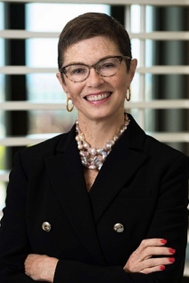 |  |  | 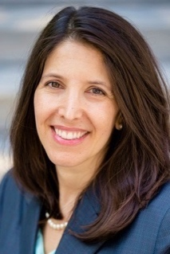 |  | 
Marguerite S. Willis  Nexsen Pruet, LLC  Columbia, South Carolina |  | Sheryl L. Axelrod  The Axelrod Firm, PC  Philadelphia, Pennsylvania |  |  |  |  |  |  | Alan Bryan  Walmart Inc.  Bentonville, Arkansas
From the Jury Room: Testing a Cybersecurity Case
with the Latest Online Jury Research Technology
 |  | 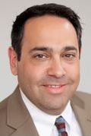 |  |  | 
Edward P. Schwartz, Ph.D., M.S.L.  DecisionQuest  Boston, Massachusetts |  |  |  |  | Ann T. Greeley, Ph.D.  DecisionQuest  State College, Pennsylvania

